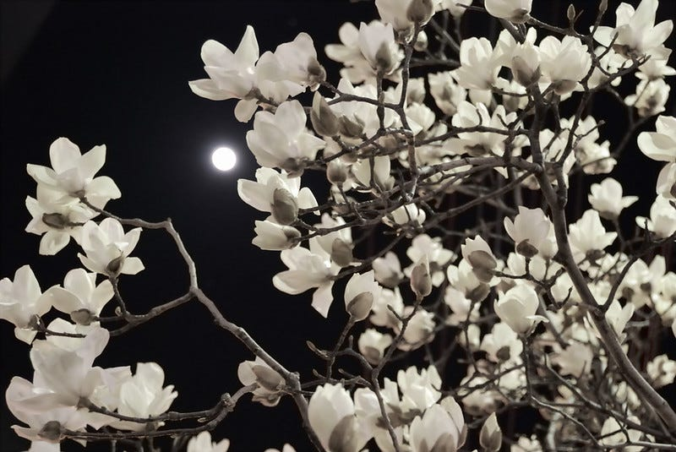

<https://medium.com/@southernhistory/magnolias-in-the-moonlight-e2da2d3124a7>

<https://kimsmithdesigns.com/tag/magnolia-soulangiana/>

Learn more about magnolias

<https://www.atozflowers.com/flower/magnolias/>

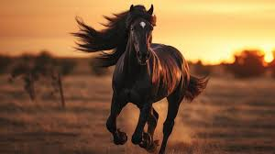

<https://stock.adobe.com/search?k=%22black+stallion%22>

https://happinessloveandlight.com/wp-content/uploads/2015/09/flowerinherheart.png

1. **Starry Night Sky**: A dark sky filled with sparkling stars, capturing the beauty of the night.
2. **Moonlit Landscape**: A landscape bathed in the soft, ethereal light of the moon, highlighting the beauty of the night.
3. **Bioluminescent Creatures**: Images of bioluminescent organisms such as fireflies, glowing jellyfish, or deep-sea creatures emitting light in the darkness.
4. **City Skylines at Night**: Pictures of city skylines illuminated by city lights against the dark night sky, showcasing the contrast between light and darkness.
5. **Northern Lights**: Stunning images of the Aurora Borealis dancing across the night sky, showcasing nature's light show in darkness.
6. **Candlelit Scenes**: Warm and cozy scenes with candlelight illuminating dark spaces, creating a romantic and intimate atmosphere.
7. **Silhouettes**: Dark silhouettes against a backdrop of light, capturing the beauty of shapes and forms in the darkness.
8. **Dark Forests**: Pictures of dense, mysterious forests at night, with moonlight filtering through the trees, creating a magical and enchanting atmosphere.
9. **Starlit Ocean**: Captivating images of the ocean under a starry sky, with the reflection of stars on the water's surface, evoking a sense of tranquility and beauty.
10. **Nighttime Skylines**: Photographs of urban landscapes at night, with illuminated buildings and structures creating a mesmerizing contrast against the dark sky.

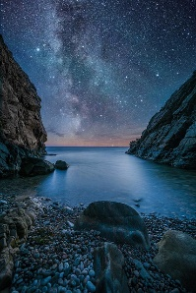https://pixabay.com/images/search/night%20sky/

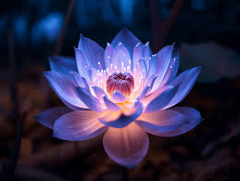 <https://www.reddit.com/r/midjourney/comments/154s20o/if_regular_flowers_were_bioluminescent/>

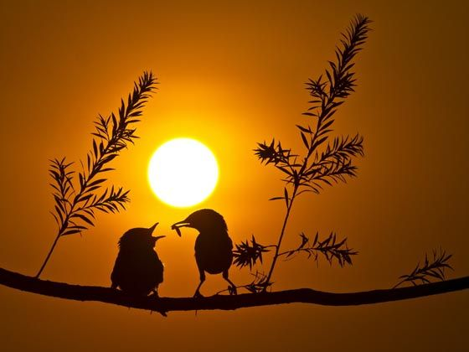

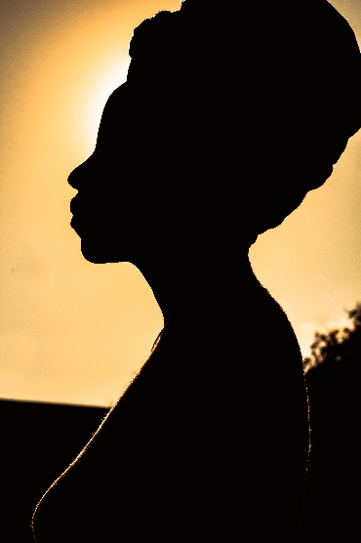 https://www.pexels.com/photo/profile-view-of-woman-silhouette-5332884/

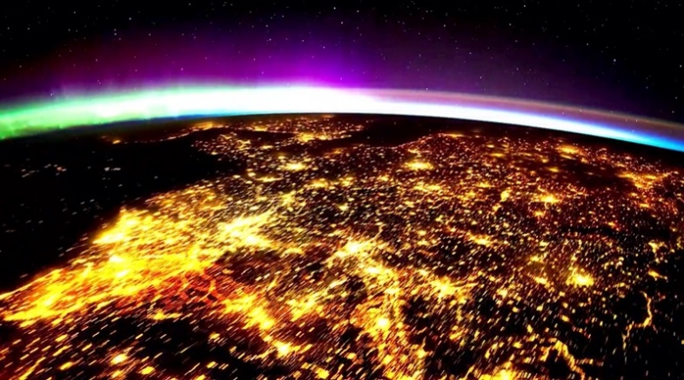 <https://candlelightstories.com/Blog/tag/international-space-station/>

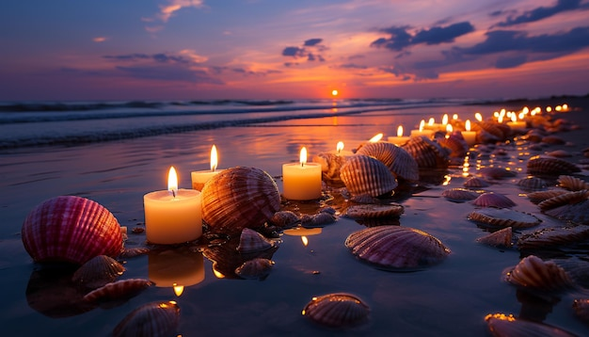  
<https://www.freepik.com/free-ai-image/relaxation-nature-candlelight-water-sand-sunset-generated-by-artificial-intelligence_77704922.htm>

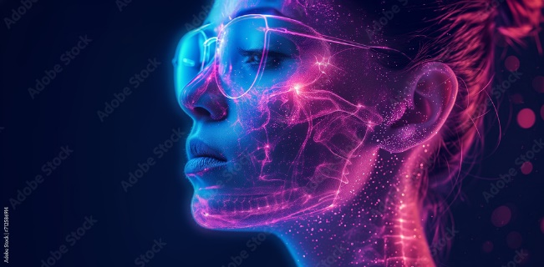 <https://stock.adobe.com/images/id/712586914?clickref=1011lyqhpZXu&mv=affiliate&mv2=pz&as_camptype=&as_channel=affiliate&as_source=partnerize&as_campaign=wbm>

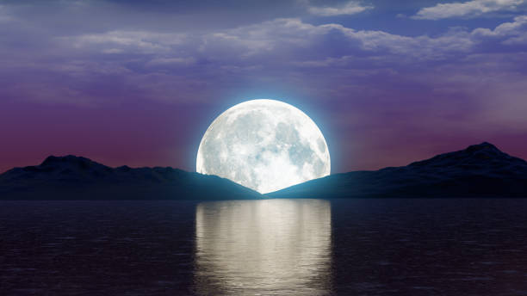 <https://www.istockphoto.com/photos/purple-sky-moon>

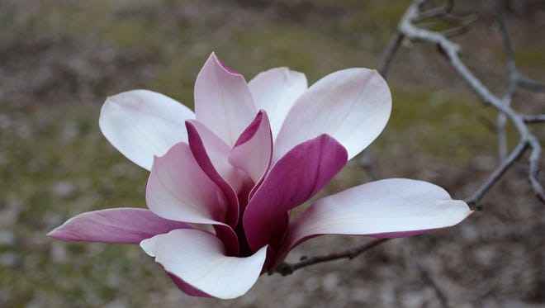 The Purple Magnolia=DignityS

https://www.greenvilleonline.com/story/life/2017/02/28/magnificant-magnolias/98539676/

**Local Specials**

Happy Hour Specials

<https://www.yelp.com/search?find_desc=Happy+Hour+Specials&find_loc=Amarillo%2C+TX>

Broome Optical Eclipse Glasses!

<https://www.myhighplains.com/news/studio-4/broome-optical-selling-eclipse-viewing-glasses/>

**Events This Week**

Mean Girls

<https://www.boxofficeticketsales.com/5857067/mean-girls-tickets-mon-4-8-2024-amarillo-civic-center-auditorium>

Garage Sales

<https://www.trianglerealtyllc.com/amarillo-garage-sales/>

Amarillo Civic Center

<https://www.amarillociviccenter.com/events/upcoming-events>

Music

Hippie Fighters

<https://www.eventbrite.com/e/a-concert-for-hippie-fighters-tickets-852050545117>

Sweet and Juicy at the 806 on Thursday

<https://www.bandsintown.com/e/105083159-sweet-n%27-juicy-at-the-806-coffee-+-lounge>

What’s happening at WT

<https://www.amarillo.com/story/entertainment/local/2024/03/31/amarillo-entertainment-in-brief-for-march-31-2024/73123327007/>